# Smart Home Control Interface – Design Specification (Dark Theme)

# Executive Summary

This document presents the complete UI/UX design specifications for a Smart Home Control Web Application in a dark theme. It includes structure, component design, screen layouts, color systems, tokens, and interaction guidelines.

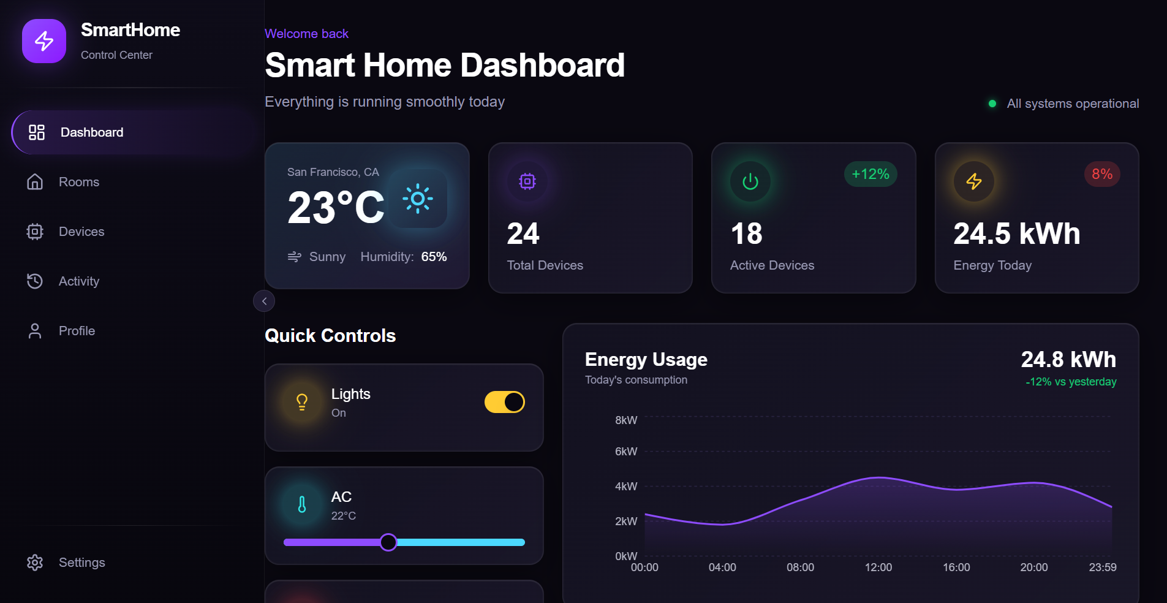

## 1. Project Structure & Information Architecture

1.1 **Primary Sections**  
- Dashboard  
- Rooms  
- Devices  
- Activity Log  
- Profile  
- Settings  
  
1.2 **Navigation Hierarchy**  
Dashboard → Quick Controls, Energy Usage, Your Rooms, Recent Activity  
Rooms → Room List → Room Detail  
Devices → Device Categories → Device Detail  
Activity Log → Alerts & Actions  
Profile → User Preferences  
Settings → System Configuration  
  
1.3 **Dark Theme Alignment**  
All backgrounds use deep purples and near-black tones for accessibility.

## 

## 2. Component-Level UI Design

2.1 Navigation Bar: Uses Surface (#120E1F), glowing accents (#9A4DFF), and hover highlights.  
2.2 Room Tiles: Card background (#151026), rounded corners.  
2.3 Device Control Cards: Show status, icon, metrics, states (active, inactive, offline, error).  
2.4 Popovers/Overlays: Elevated surface (#1B162E).  
2.5 Activity Notifications: Toast-style with semantic colors.

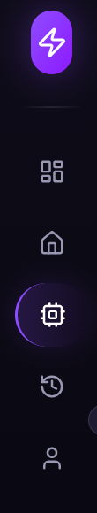 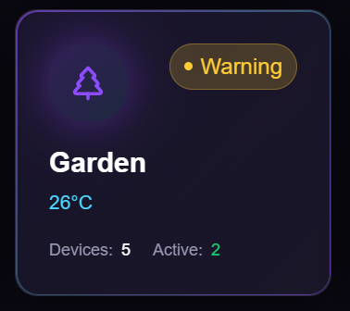

## 3. Main Dashboard Layout

Includes weather tile, device counts, energy usage, quick controls, and recent activity. Uses 4-column grid, neon accents, and clean spacing.

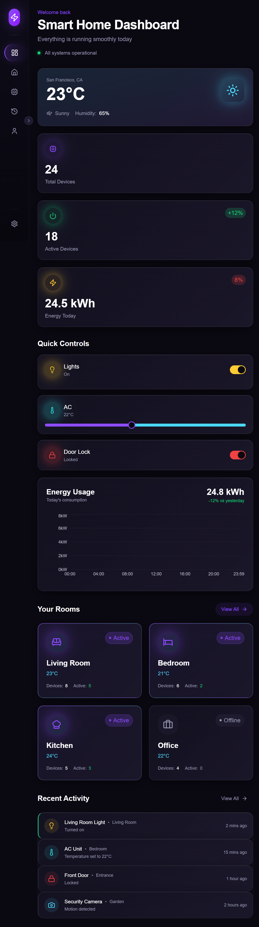

## 4. Room View

Shows room name, device counts, scene modes, and 3-column device grid.

## 

## 5. Device Detail View

Includes device icon, name, power toggle, sliders, controls, and recent activity list.

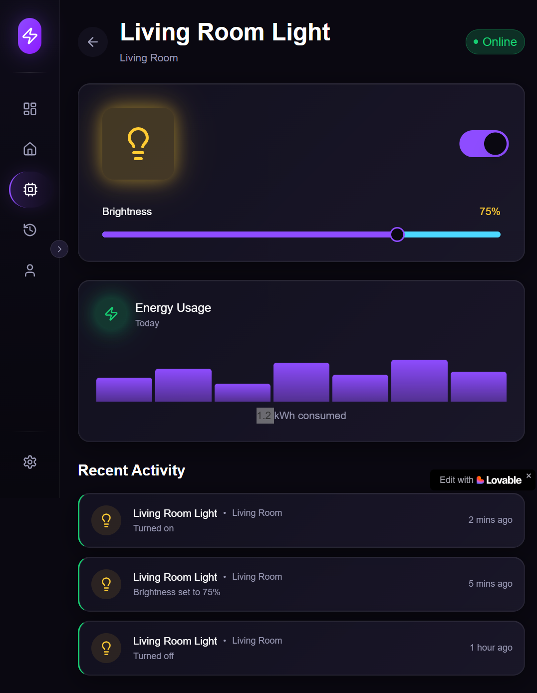

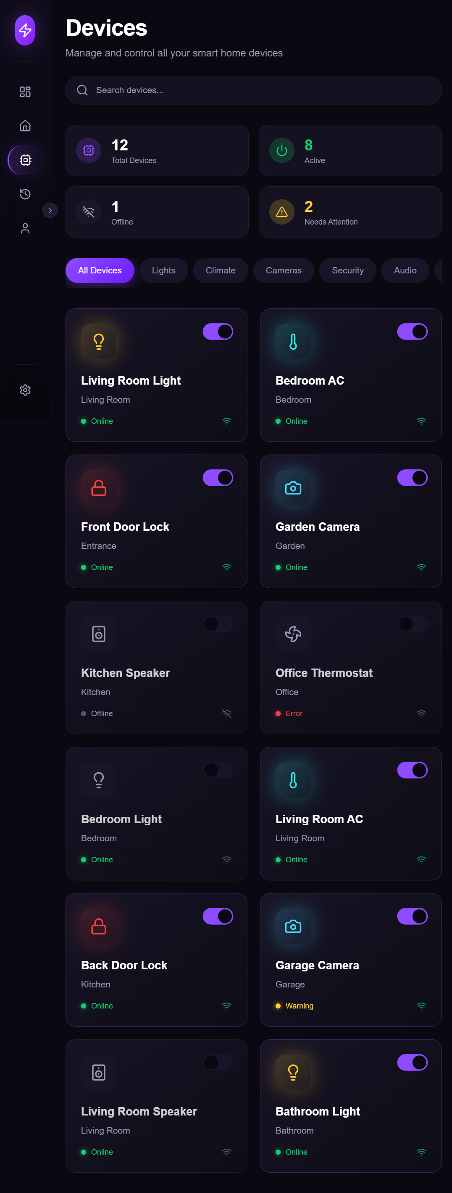 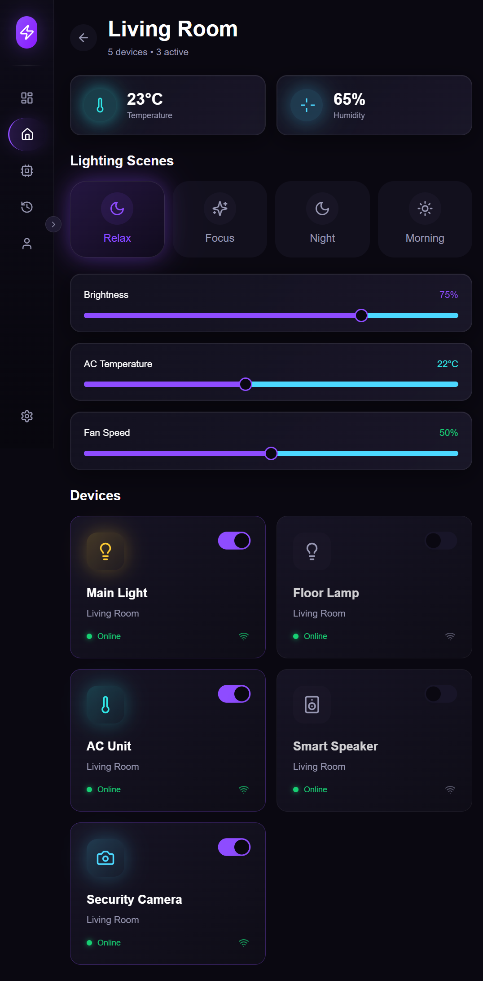

## 6. Activity Log

It tracks all device activities and events in your home.

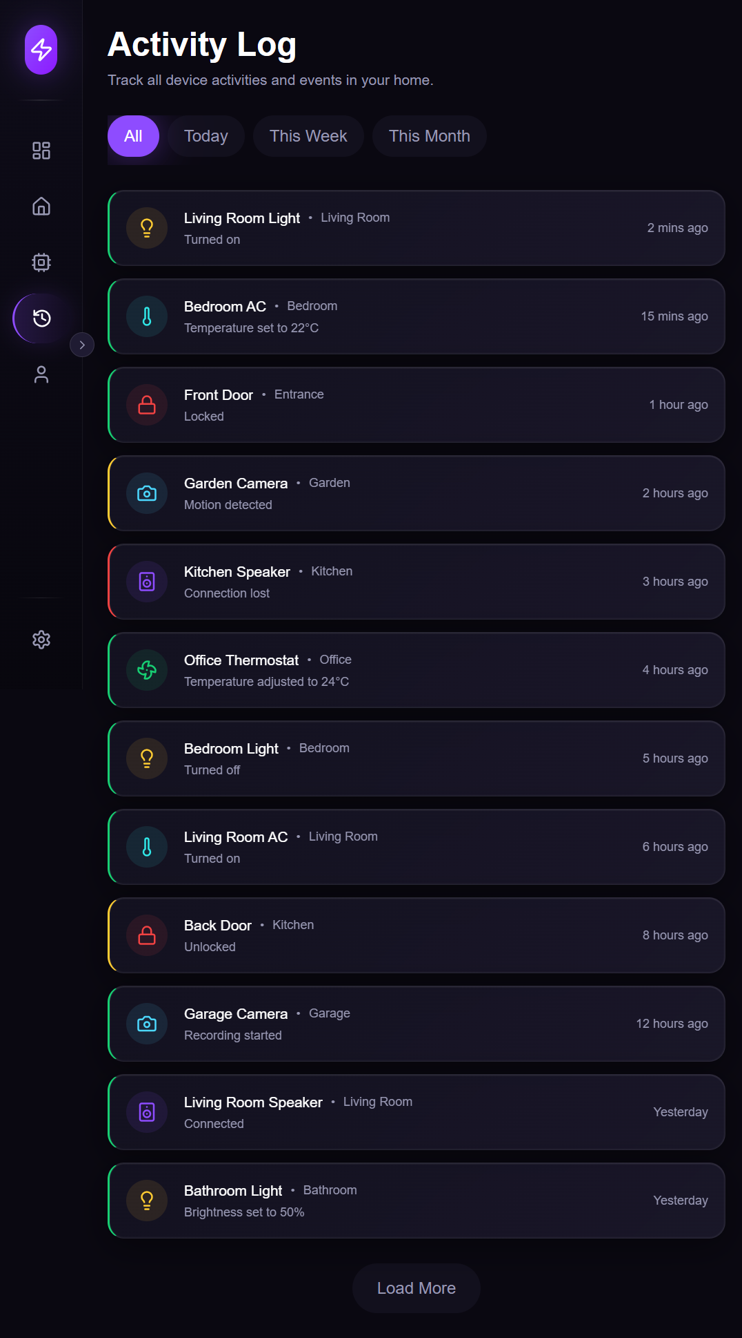

## 7. Profile

Manage your personal information and preferences.

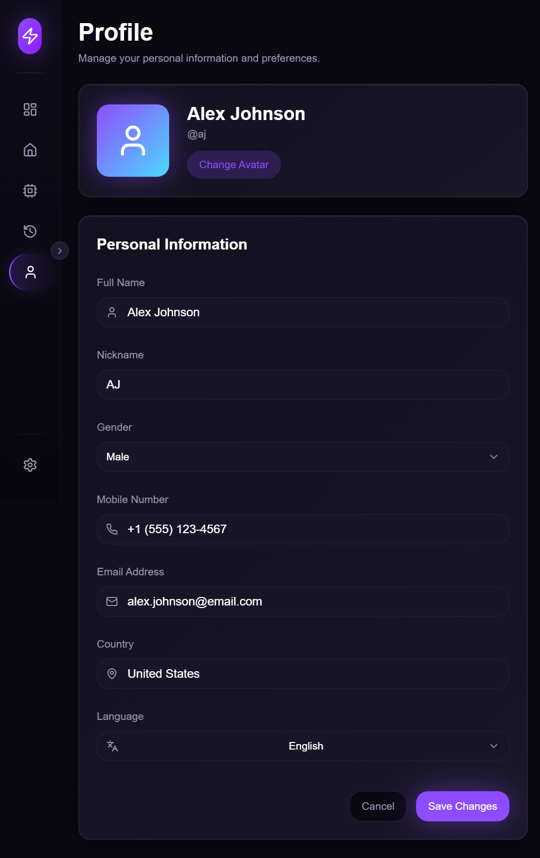

## 8. Interaction Guidelines

Hover → Glow effect  
Active → Slight scale down  
Focus → Purple ring (#9A4DFF)  
Loading → Pulsing indicator  
Error → Red highlight (#FF5959)

## 9. Color & Typography System

Primary Neon Purple: #9A4DFF  
Secondary Electric Blue: #33D7FF  
Background: #0A0714  
Surface: #120E1F  
Elevated Surface: #1B162E  
Card: #151026  
Dim Text: #B3B3C7  
Accent Yellow: #FFCC33  
Accent Teal: #2CD9CC  
Accent Red: #FF5959  
Accent Green: #33CC7F  
  
**Typography:**  
Titles: 32–36px  
Headings: 22–24px  
Card Titles: 18px  
Body: 14–16px  
Caption: 12px

## 10. Design Tokens

Spacing: 4 / 8 / 12 / 16 / 24 / 32 / 48 px  
Radii: 12–24px  
Shadows: Neon glow  
Animation: 150–250ms ease-in-out

## 11. Constraints & Assumptions

* Dark theme only
* Neon icon style
* User has pre-configured rooms and devices.

Presented by – Sai Durga Sirisha Toram